PARTICIPANT CLOTHING/EQUIPMENT CHECKLIST (SUMMER)

Summer could bring temperatures of +10 to +30C, plan to bring layers for cooler days. Please bring casual, comfortable clothing suitable for on-the-land activities. Expect about 18 hours of daylight, with lots of sunlight. Expect extreme bug conditions—bug jackets are essential, not optional.

We think you will find the following items especially useful during your stay. If you do not have any of the following please let us know.

Please note: there will be no laundry available and there will be not internet available. There is cell service.

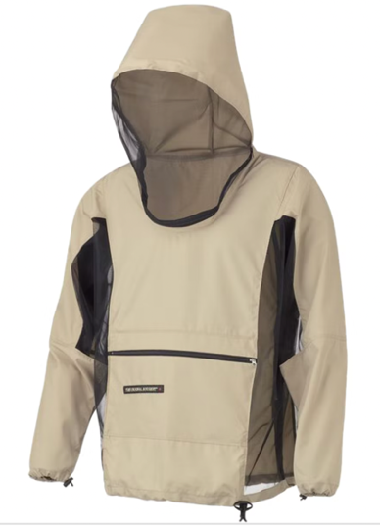  Bug jacket | 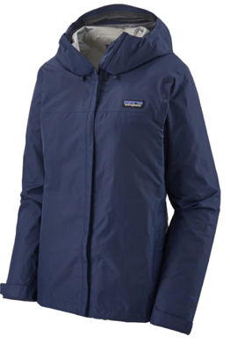  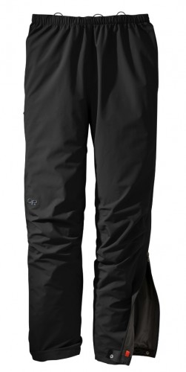  Rain gear (jacket with hood and pants)
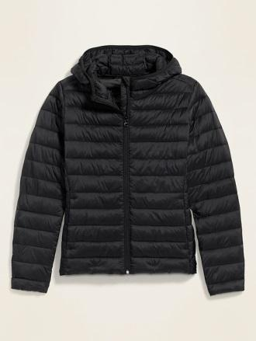  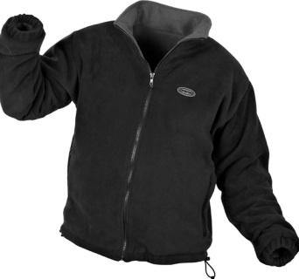  1 warm sweater or jacket | 1 set of thermal underwear layers, a shirt and pants (wool, polypro, avoid cotton) 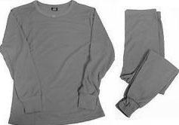
Shirts for 13 days on the land. Likely just 2-4. (sweat-wicking, breathable, quick dry are best but not mandatory) | 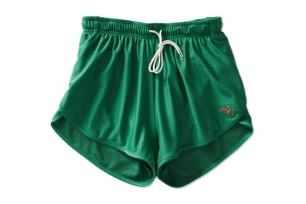  Shorts (quick dry, active)
3 pairs of long pants that can fit over thermal underwear/base layer.  - Work pair: don’t mind getting dirty, durable, breathable, quick dry  - Hiking pair: breathable, quick dry  - Warm pair: fleece, cotton sweatpants  *think: cover ankles for bugs!!  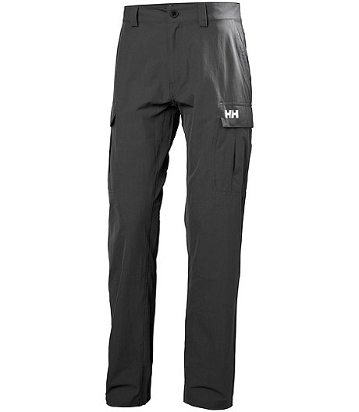 | 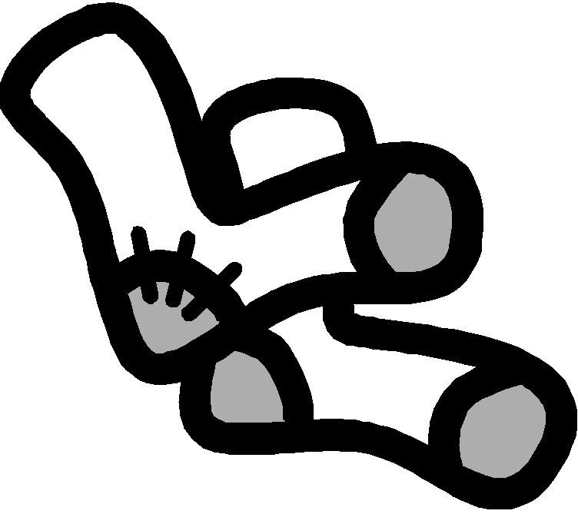  3-7 pairs of wool socks
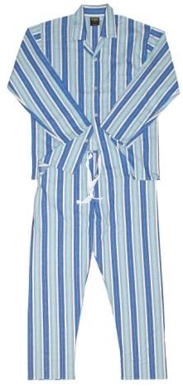  Pyjamas! | 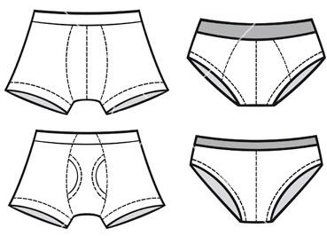  Underwear
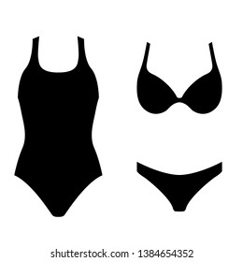  Bathing suit  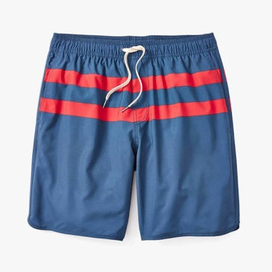 | 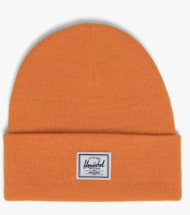  Toque
Work gloves (try to get ones that will protect your hands from bugs—bugs can’t crawl in them or your sweater/jacket can go over them)  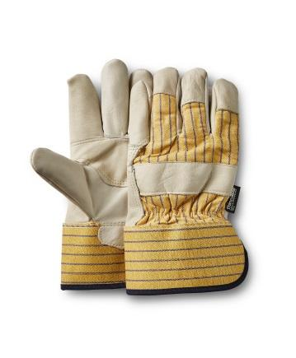 | Sun hat  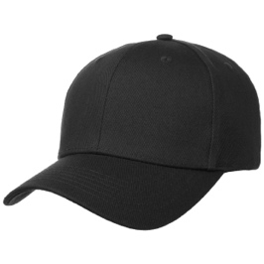
Runners or hiking shoes  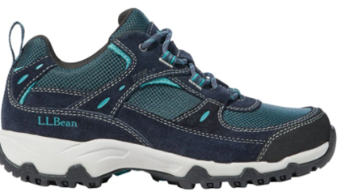 | Mask(s)!  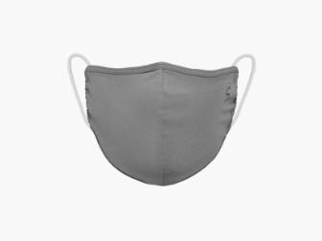
Sandals that can get wet and/or dry fast (not flip flops) | Personal toiletries  - Comb/Brush  - Toothbrush and paste  - Deodorant  - Full set tampons, pads, diva cup, etc. (even if you may not need them)  - Etc.  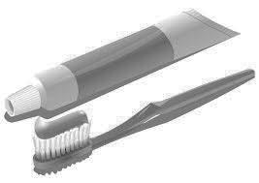  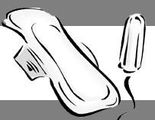
Bug Spray  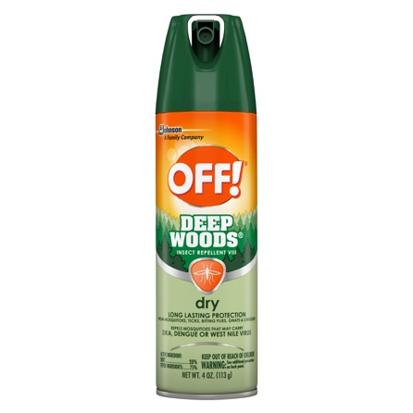 | Bug net (for sleeping)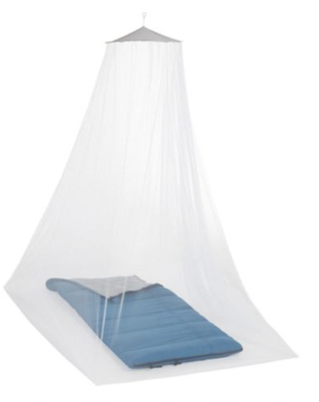
Afterbite  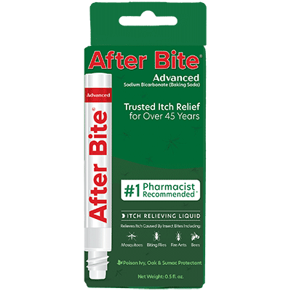 | Sleeping sheet/sleeping bag liner
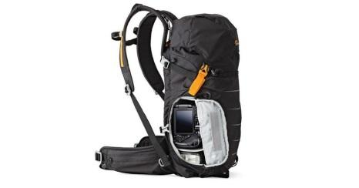  Day pack (small backpack) | Sunscreen
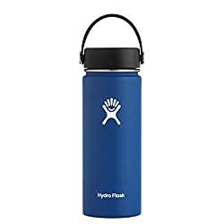  Water bottle | Moisturizer
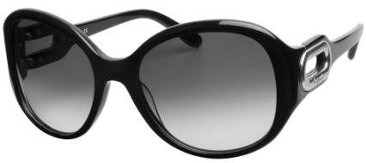  Sunglasses | Lip balm (with SPF protection)  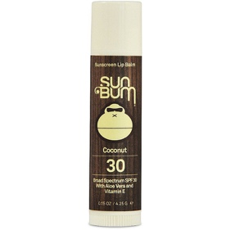
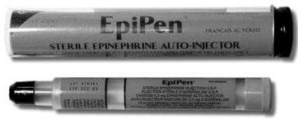  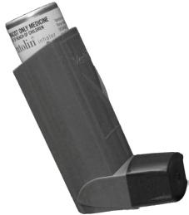  Medications if required (bring two inhalers or Epi-pens) | 1 pillow
- Towel | Course materials, notepad, pen/pencil, etc.

OPTIONAL ADDITIONS

Optional Checklist—🗹 when packed
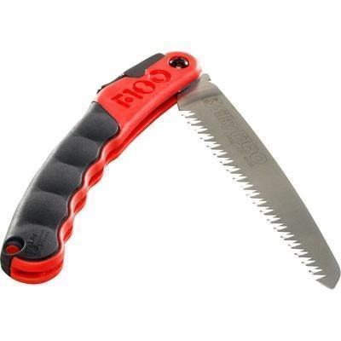  Bush tools (saw, knives, matches, lighter, etc.) | 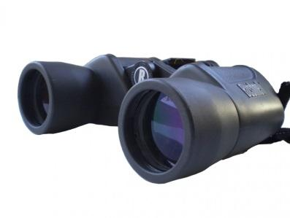  Binoculars
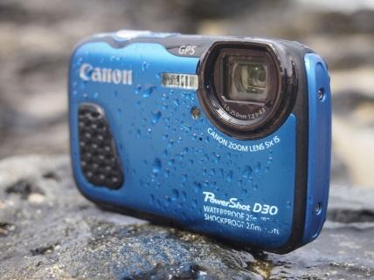  Camera (know it can be damaged) | Portable battery charger  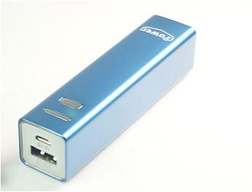
Sewing/beading projects  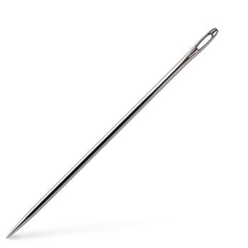 | Books, cards.
Self-care items for free time (smudge, drum, headphones to listen to meditation/music, journal, etc.) 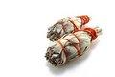 | Snacks/Treats
Small tokens of appreciation for Elders and knowledge holders | Sleeping eye mask (we are the land of the midnight sun) and ear plugs  